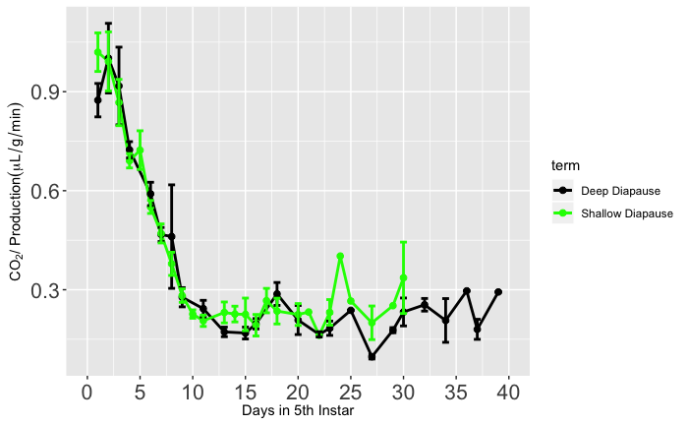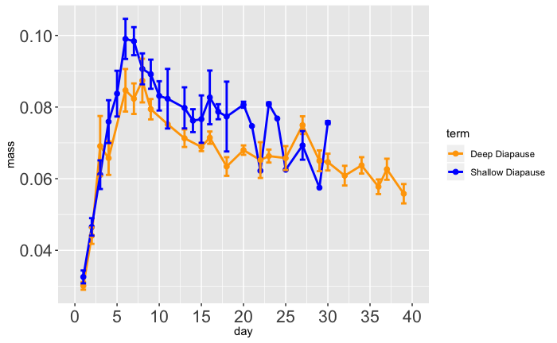

CO2 Production (µ/g/min)

(Short-Diapause Genotype)

Wet Mass (g)’

(Short-Diapause Genotype)

**B**

Time (days)

**Deep Diapause**

**Shallow Diapause**

**A**

**Deep Diapause**

**Shallow Diapause**

Time (days)